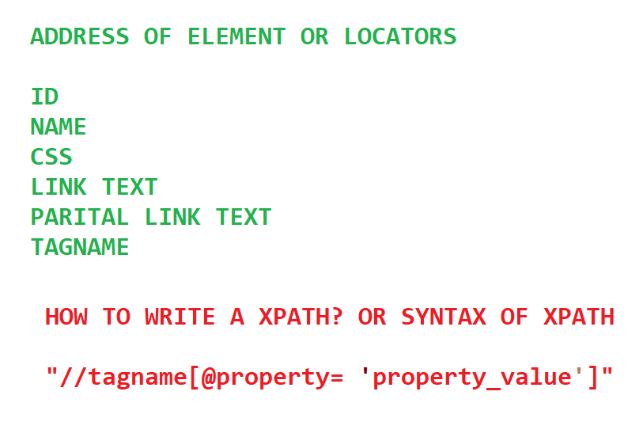

Two plug in available to get xpath of webelement

In Chrome

1. Chropath

<https://chrome.google.com/webstore/detail/chropath/ljngjbnaijcbncmcnjfhigebomdlkcjo?authuser=19&hl=de>

1. Selectorshub

https://chrome.google.com/webstore/detail/selectorshub-xpathplugin/ndgimibanhlabgdgjcpbbndiehljcpfh

Both of them are free

Xpath Example of username

https://www.saucedemo.com/

//input[@placeholder='Username']

//input[@data-test='username']

//input[@id='user-name']

//input[@name='user-name']

//input[@type='text']

Note : Below xpath will give you two elements

//input[@class='input_error form_input']

<https://www.testandquiz.com/selenium/testing.html>

//a[@href='https://www.javatpoint.com/']

//a[contains(text(),'This is a link')]

//input[@id='fname']

//button[@id='idOfButton']

//input[@id='female']

//input[@class='Automation']

or

//input[@value='Automation']

**ASSIGNMENTS**

Go to <https://opensource-demo.orangehrmlive.com/>

**Write xpath for following elements without using chropath or selectors hub and verify the xpath**

**USERNAME**

**PASSWORD**

**LOGIN**

**FORGOT PASSWORD**

**OrangeHRM link on the bottom**

**Admin**

**PIM**

**Leave**

**Time**

**Recruitment**

**Under Admin- Add,Search, Reset,Delete**

* To verify- Right click Inspect Element- Click on Element option on developer tools then click Ctrl+F in keyboard
* To launch developer tools either Right click on the page and Inspect
* If Right click is disabled then press F12(Function+F12)